**Web Hackathon Challenge 2**

**UI supports the following features :-**

1. **Expose API to store the latitude, longitude and optional userId**
2. **If the user Id is not given Database automatically generates a unique Id.**

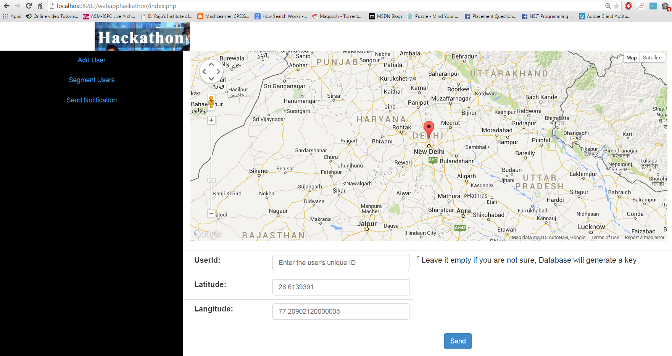

**API to save the Locations**

**Click on “Add User” – to add user location and ID**

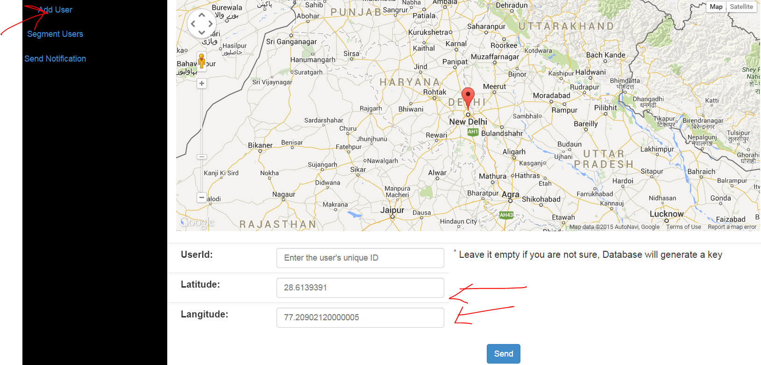

Click on Segment users to see the newly added location

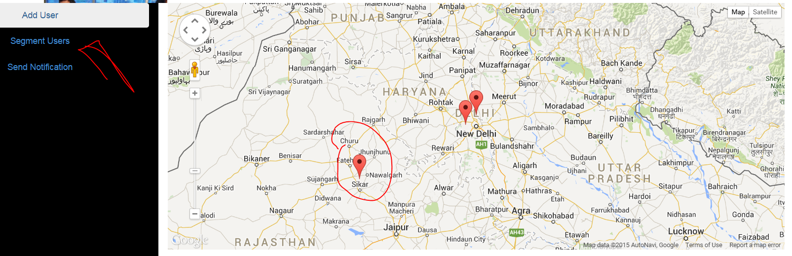

In “segment Users Tab”

